Figure 1: Energy Production 1

Figure 2: Total Farm Production for All Farms in Oregon 2

Figure 3: Proportion of Errors 2

Figure 4: Natural Filtration 3

Figure 5: Publication Process 3

Figure 6: Distribution of low-density lipoprotein 4

Table 1: Energy production by major source from 1960 to 19801 1

Table 2: Proportion of Errors in Younger and Older Groups 2

# Lorem ipsum file for Visualizations Lab:

Lorem ipsum dolor sit amet, consectetuer adipiscing elit. Maecenas porttitor congue massa. Fusce posuere, magna sed pulvinar ultricies, purus lectus malesuada libero, sit amet commodo magna eros quis urna. Nunc viverra imperdiet eni.

|  |  |  |  |  |  |
| --- | --- | --- | --- | --- | --- |
| **Table 1: Energy production by major source from 1960 to 19801** | | | | | |
| **Year** | **Total production (quad Btu)** | **Percent production** | | | |
| **Coal** | **Petroleum** | **Natural gas** | **Other2** |
| 1960 | 41.5 | 26.1 | 36.9 | 34.0 | 3.9 |
| 1970 | 62.1 | 23.5 | 32.9 | 38.9 | 4.7 |
| 1980 | 64.8 | 28.7 | 28.2 | 34.2 | 8.9 |

1Source: U.S. Energy Information Administration*, Annual Energy Review*

2Includes hydropower, nuclear power, geothermal power, and others.

Figure 1: Energy Production

Lorem ipsum dolor sit amet, consectetuer adipiscing elit. Maecenas porttitor congue massa. Fusce posuere, magna sed pulvinar ultricies, purus lectus malesuada libero, sit amet commodo magna eros quis urna. Nunc viverra imperdiet eni.

**Total Output of All Farms in Oregon**

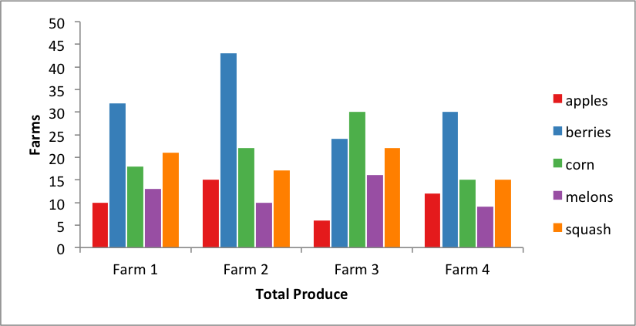

1Source: U.S. Department of Agriculture

Figure 2: Total Farm Production for All Farms in Oregon

Fusce est. Vivamus a tellus. Pellentesque habitant morbi tristique senectus et netus et malesuada fames ac turpis egestas. Proin pharetra nonummy pede.

Mauris et orci. Aenean nec lorem. In porttitor. Donec laoreet nonummy augue.

Table 2: Proportion of Errors in Younger and Older Groups

|  |  |  |  |  |  |  |  |
| --- | --- | --- | --- | --- | --- | --- | --- |
|  | Younger | | |  | Older | | |
| Level of difficulty | *n* | *M (SD)* | 95% CI |  | *n* | *M (SD)* | 95% CI |
| Low | 12 | .05 (.08) | [.02, .11] |  | 18 | .14 (.15) | [.08, .22] |
| Moderate | 15 | .05, (.07) | [.02, .10] |  | 12 | 17 (.15) | [.08, .28] |
| High | 16 | .11 (.10) | [.07, .17] |  | 14 | .26 (.21) | [.15, .39] |

*Note CI = confidence interval.*

*Note M (SD) = mean and standard deviation*

1Source: The “Errors” table is from “Generations,” by L.G. Elias and C.C. Bent, 2002, Journal of Geriatric Care, 5, p. 22

Figure 3: Proportion of Errors

Lorem ipsum dolor sit amet, consectetuer adipiscing elit. Maecenas porttitor congue massa. Fusce posuere, magna sed pulvinar ultricies, purus lectus malesuada libero, sit amet commodo magna eros quis urna.

Nunc viverra imperdiet enim. Fusce est. Vivamus a tellus.

Pellentesque habitant morbi tristique senectus et netus et malesuada fames ac turpis egestas. Proin pharetra nonummy pede. Mauris et orci.

Aenean nec lorem. In porttitor. Donec laoreet nonummy augue.

Suspendisse dui purus, scelerisque at, vulputate vitae, pretium mattis, nunc. Mauris eget neque at sem venenatis eleifend. Ut nonummy.

Fusce aliquet pede non pede. Suspendisse dapibus lorem pellentesque magna. Integer nulla.

**Natural Water Filtration and Extraction Diagram**

A close up of a water filtration system using sand.



1Source: The Water Filtration Organization

Figure 4: Natural Filtration System

Suspendisse dui purus, scelerisque at, vulputate vitae, pretium mattis, nunc. Mauris eget neque at sem venenatis eleifend. Ut nonummy. Fusce aliquet pede non pede.

Suspendisse dapibus lorem pellentesque magna. Integer nulla. Donec blandit feugiat ligula. Donec hendrerit, felis et imperdiet euismod, purus ipsum pretium metus, in lacinia nulla nisl eget sapien.

**Book Publication Process Diagram**

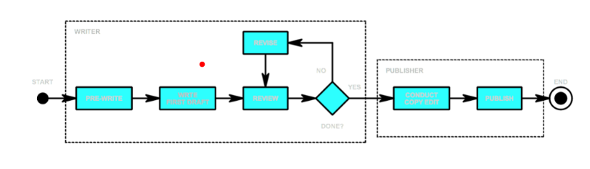

1Source: Publication Process Organization

Figure 5: Book Publication Process

Lorem ipsum dolor sit amet, consectetuer adipiscing elit. Maecenas porttitor congue massa. Fusce posuere, magna sed pulvinar ultricies, purus lectus malesuada libero, sit amet commodo magna eros quis urna. Nunc viverra imperdiet enim.

Fusce est. Vivamus a tellus. Pellentesque habitant morbi tristique senectus et netus et malesuada fames ac turpis egestas. Pro in pharetra nonummy pede.

**Distribution of LDL Graph**

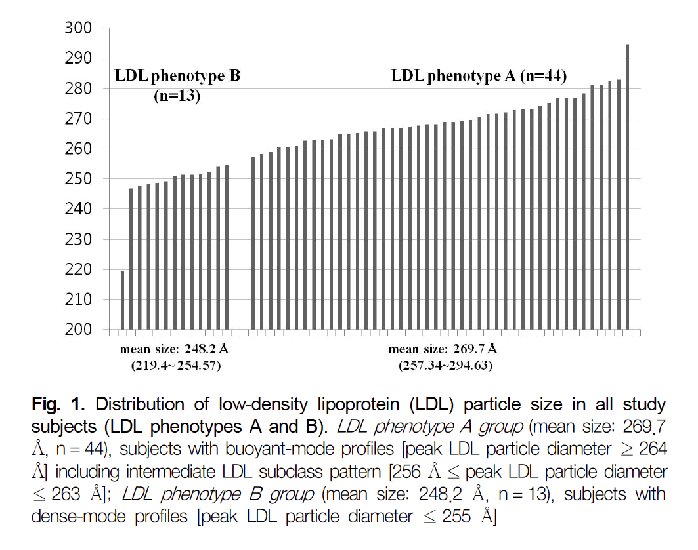

*Note LDL = low-density lipoproteins*

1Source: Johns Hopkins LDL Abstract

Figure 6: Distribution of low-density lipoprotein

Mauris et orci. Aenean nec lorem. In porttitor. Donec laoreet nonummy augue.

Suspendisse dui purus, scelerisque at, vulputate vitae, pretium mattis, nunc. Mauris eget neque at sem venenatis eleifend. Ut nonummy. Fusce aliquet pede non pede.

Suspendisse dapibus lorem pellentesque magna. Integer nulla. Donec blandit feugiat ligula. Donec hendrerit, felis et imperdiet euismod, purus ipsum pretium metus, in lacinia nulla nisl eget sapien.

Donec ut est in lectus consequat consequat. Etiam eget dui. Aliquam erat volutpat. Sed at lorem in nunc porta tristique.

Proin nec augue. Quisque aliquam tempor magna. Pellentesque habitant morbi tristique senectus et netus et malesuada fames ac turpis egestas. Nunc ac magna.